UNITED STATES MILITARY ACADEMY

FINAL TECHNICAL REPORT

SE450: APPLIED SYS DSGN/DECISN MAKING

SECTION C1

MAJ BIANCHI

By

The Decision Makers
CADET AARON MALLORY ’12, CO H4
CADET ANDRE SHINDA ’12, CO D1
CADET JASON JIN ’12, CO C3
CADET SAMUEL EDET ’12, CO F3

WEST POINT, NEW YORK

30 NOVEMBER 2011

_____ MY DOCUMENT IDENTIFIES ALL SOURCES USED AND ASSISTANCE
RECEIVED IN COMPLETING THIS ASSIGNMENT.

_____ I DID NOT USE ANY SOURCES OR ASSISTANCE REQUIRING
DOCUMENTATION IN COMPLETING THIS ASSIGNMENT.

The decision Makers
JPOD System
Final Tech Report
CADET AARON MALLORY ’12, CO H4
CADET ANDRE SHINDA ’12, CO D1
CADET JASON JIN ’12, CO C3
CADET SAMUEL EDET ’12, CO F3
[30NOV2011]
Table of Contents
Executive Summary……………………………………………………………………..…..…...v
- Introduction………………………………………………………………………..………...1
  - Purpose of Report……………………………………………………………..…….…..1
  - Organization of Report……………………………………………………..………..….1
- Background
  - Current Situation and Problem…………………………………..……………..……..…1
  - Stakeholders…………………………………………………………………..……....…2
  - System Component, Function, Hierarchy, and State……………………...………..……3
  - Desired Outputs…………………………………………………………..……….……..4
  - Scope and Boundary……………………………………………………..……………....5
  - Underlying Need………………………………………………………….…….…….…5
- Recommendation………………………………………………………………..…………....6
- Method/Technical Approach………………………………………………………….….......6
  - System Goals and Subsequent Supporting Objectives……………………….…………6
  - Defined Criteria………………………………………………………….……………...7
  - Modeling Assumptions…………………………………………………….……………8
  - Alternatives……………………………………………………………….……………..8
- Analysis……………………………………………………………………………....……....9
  - Feasibility Screening Matrix…………………………………………………….………9
  - Candidate Scoring………………………………………………………………….…..10
  - Cost……………………………………………………………………………………..12
  - Cost vs. Value…………………………………………………………………………..12
  - Sensitivity Analysis……………………………………………………………………..13
- Implementation……………………………………………………………………………...13
- Conclusion……………………………………………………………………………...…...14
- Appendices………………………………………………………………………………….15
Works Cited………………………………………………………………………..……………23
Executive Summary
In an effort to make transportation around West Point more efficient for not only cadets but residents and visitors alike, our group set about understanding a new type of transportation system: the JPOD. This transportation system consists of a pod-like vehicle capable of holding four occupants at a time. It is suspended overhead by a track, and has the capability of lowering itself from the track to the ground and moving people closer to their destination. Our goal essentially is to cater to the needs of everyone within West Point which so that everyone can use the JPOD system to best fit their demands. Our next task was to rate each solution base off how well it aligns with what the people want (value) against how much it would actually be (cost).
First we used a survey to gather empirical data from the corps of cadets, and conducted interviews with civilian workers, as well as the residents of West Point and greater towns of Highland Falls and Garrison. The goal here was to find out what exactly people wanted as far as transportation goes, and how we could best tailor the JPOD system to best fit everyone’s needs. From this data, we were able to get a general idea as to what components of the system were priorities. This coupled with two formal meetings with LTC Lachance allowed us to figure out the value measures that were most important to the system and the least important. This fulfilled the value portion.
Next, our group gathered information on how much it would cost to not only build a JPOD system, but to procure the materials and hire workers. This required us to initiate a correspondence with Bill James, the creator of the JPOD system, to ask him directly what it would cost to build, run, and maintain the system. Mr. James was able to provide us some hard numbers as far as materials and running the system goes, but the task be felled us to research the actual worker costs. We compiled all the costs, and figured how much it would cost to run the system for x amount of miles. This fulfilled the cost portion, and from this, we created a cost vs. value chart that depicted our results for the candidate solutions.
Finally from our research and math we created cost vs. value relationships for each candidate solution for the potential buyer to peruse. This graph clearly depicts the best options based on what the people want in their system next to a price. Our findings indicate that Route “Knockout” was the best solution that was low in cost, and high in value meaning it closely aligned with the people and stakeholder’s needs, wants, and desires. Our final endeavor would be to get the go ahead from LTC Lachance to begin the project.
Some future work that would follow the system would include system upkeep, which is how much money it would take to repair the system and keep it running like new, paying workers who work on it, and any damages from inclement weather. Work to increase track length to make the system more readily available to those out of range might factor into costs as well. Overall the system has the capability of taking on improvements as well as getting repaired.
- Introduction
  - Purpose of Report
The purpose of this Interim Technical Report is to in depth discuss key components of the Interim Progress Report which recaps the progress made on finding a way to implement the JPOD system. This would include giving a brief introduction of the problem team Decision Makers has been tasked to solve and going over the background of the problem. The report outlines the means of getting to the desired end state which is a practical and efficient solution that can be implemented at West Point and how we eliminated alternative solutions that would work but did not satisfy given cost verses value. Thus, we intend to in-depth review the process taken to arrive at a candidate solution and show why we believe it is the best feasible option.
  - Organization of Report
Once familiarization is conducted, the report will discuss our recommendation and support this recommendation with justified information. The report will then review the analysis done, means of implementing the project, and finish the report with a conclusion. Holistically, the report breaks down into eight general sections that will give the reader a broader idea of our work and allow the reader to take their visualized concept and see how that concept can be applied to the real world.
- Background
  - Current Situation and Problem
The problem tasked to team Decision Maker is finding the most feasible means of implementing a JPOD system in and around West Point. This task is relevant because in April 2011, West Point was chosen as an Army Net Zero Installation. This identification means that West Point must consume as much energy as it is capable of producing (Army Net Zero Initiative). To try and achieve this goal of the Army Net Installation, the idea of placing a JPOD system around West Point was proposed. The JPOD is a transportation system that runs off of solar energy and would eliminate the need for cars on post. In order to become more knowledgeable of the conservation of energy and the different fields associated with it, research in the fields of Net Zero Initiative, the “Going Green” concept, the JPOD system, and Personal Rapid Transit are conducted for familiarization purposes.
  - Stakeholders
The stake holders for this project are COL. Lachance, Bill James, and Warren Geiger, USMA faculty, families, cadets, Garrison of USMA, Hudson River Preservation Society, Balfour Beatty, tourist, and Highland Falls residents. COL Lachance is the decision maker for the JPOD project and our class. As chair of the Army Net Zero Counsel, COL Lachance is responsible for implementing ideas that allow West Point to go green. Bill James and Warren Geiger are the developers of the JPOD system. Balfour Beatty, Garrison residents, and Highland Falls residents care about how the JPOD will affect the property in their respective communities. The Hudson River Preservation Society cares about preserving the environmental history of the Hudson. Cadets, Staff, Faculty, and families care about their transportation and ease of travel around post. These individuals will be the main users of the JPOD system. Secondary users of the system will be the tourist. If implemented correctly, the JPOD will be able to go from the West Point visitor center to historic sites around the installation. To further understand the Stakeholder, surveys an analysis was conducted and summarized into, findings, conclusions, and recommendations. This research allows for a better assessment of each stakeholders imprint on how to create a feasible solution that addresses everyone’s wants and needs. Through discussion, many of the stakeholders suggested that we consider the impact the system would have on preserving the authenticity of the environment and historic locations. Stakeholders also suggested that we consider building JPOD’s big enough for a group and not just one individual. The potential user also recommended multiple stops so that they could access locations all throughout the post.
  - System Component, Function, Hierarchy, and State
In its most basic form the JPOD is a physical man made personnel transit system. The goal of the JPOD is to move personnel and cargo just like a train or car. In order to move personnel, the JPOD system will consist of components such as solar panels, tracks, pods, and high tech computers. The JPOD is a complicated system to the average person and is a black box. This means that the individual has a very basic understanding of the system. To the Decision Makers the JPOD is a grey box. This is because we have a limited understanding of the system but we don’t understand the science behind how the system operates. To Bill James and Warren Geiger, the system is a white box. The JPOD system is a white box to the creators because they understand every process included in the JPOD system. Overall, the main function of the JPOD is to transport personnel. The functional hierarchy in figure 2 analyzes the requirements of the stakeholders. The highest level objective for our hierarchy, implement JPOD, is the objective that the stakeholder is trying to achieve. To achieve this, the system is broken down into functions that will facilitate in attaining the goal of “implement JPOD”. Our research focused our functions down to five: provide convenience, secure passengers, transport personnel, preserve West Point, and reduce emissions. To achieve these functions, objectives are assigned that will facilitate the fulfillment of attaining each function. The final row of the hierarchy is the Value measures, which show qualitative measure to achieve the functions. The fundamental objective also identifies inputs, outputs, controls, and mechanisms for the IDEF0 depicted in appendix F. Inputs into the system are the JPOD and the West Point community and the outputs would be transported personnel, less traffic, and cleaner emissions. Controls that apply to the JPOD System are West Point building codes, Federal budget, and EPA regulations. The mechanisms for the system which affect the outputs are the JPOD driver, rails/cars, routes, and solar power/electricity.
  - Desired Outputs
The inputs consumed by the JPOD system are tracks, pods, and stations. The consumed inputs produce the desired outputs of transported passengers and cargo. These inputs contribute to developing the routes and most sufficient means of implementing at JPOD at a location. With more than one alternative route, our job is to identify the most effective candidate route that will please our stakeholders.
Scope and Boundary
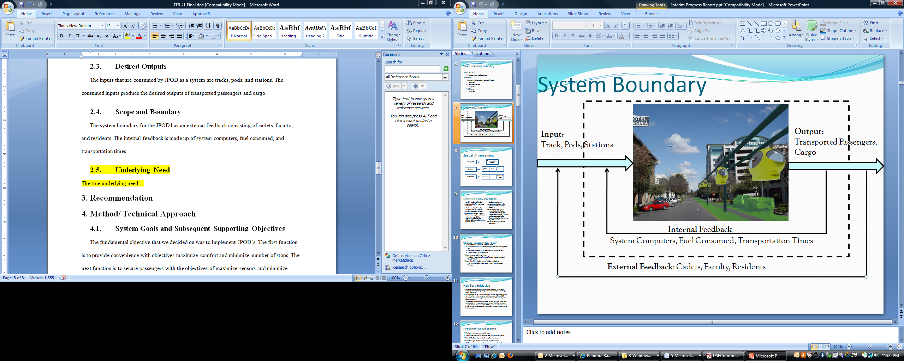
The system boundary for the JPOD has an external feedback consisting of cadets, faculty, and residents. The internal feedback consists of system computers, fuel consumed, and transportation times.

Figure 1 System Boundary
  - Underlying Need
There is a need for the JPOD system at West Point because this system is an efficient way to transport personnel around West Point and meet the goals of the Army Net Zero Initiative. Meeting the goals of the Army Net Zero Initiative is important because America is becoming a green country. As a landmark of the United States, West Point has a responsibility to meet both the nation’s goals and the army’s goals. Thus, through research and further talking to the stakeholders, are redefined problem statement is what is the best way to implement the JPOD system in and around USMA, where the system will preserve West Point, promote efficiency, and effectively transport passengers.

- Recommendation
Based off of our research, analysis, and mathematical work we created a cost vs. value model that graphically depicts the route best suited for the West Point Community. We examined our five other candidate solutions plotted on the graph and found that they either are too expensive, or provide a low value. Our goal is to maximize the value of the route, and minimize the amount it would cost. Route “Knockout” has the highest value at the lowest cost. Therefore, we recommend “Knockout” as a solution to the redefined problem statement.
Method/ Technical Approach
  - System Goals and Subsequent Supporting Objectives
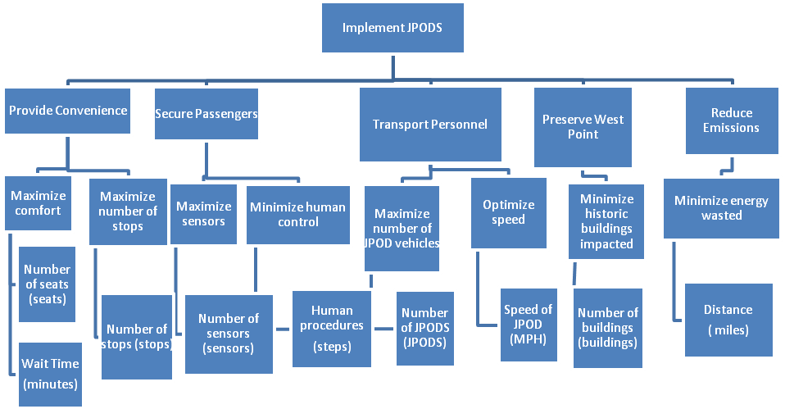
Figure 2 Value Hierarchy
The fundamental objective for this system is Implement JPOD’s. The first function is to “provide convenience” with objectives “maximize comfort” and “maximize number of stops.” The next function is to “secure passengers” with the objectives of “maximize sensors” and “minimize human control.” After that, “transport personnel” is another function with the objectives of “maximize number of JPODS” and “optimize speed.” The fourth function is “preserving West Point” and it has the objective of “minimizing number of buildings impacted.” The last function is to “reduce emissions.” The objective of this is to “minimize the energy wasted.”
  - Defined Criteria
To asses each objective, we assigned value measures to each one as a means of determining measures of performances. For example, if we wish to maximize the leg room in our JPODs, alternatives that fulfill this requirement are sufficient to meeting this requirement. Those that do not meet the set requirement will be screened out. We assigned each objective a word describing the most optimal end sate: maximize, minimize, or optimize. Once we defined the specific criteria, we talked with the main stakeholder to determine the top three important values. These three – number of stops, human procedures, and wait time – were selected to be the screening criteria for the feasibility screening matrix (see Appendix B)..
  - Modeling Assumptions
The first assumption being that the system will function once implemented; there are things we are not analyzing due to the scope we must consider. So, we are assuming that with everything we considered that the system will work in the end. The second assumption is the system will be self sustaining. One of the objectives of our stakeholders is to reuse and recycle energy. Thus, we are assuming that the JPODs can effectively sustain and power themselves. Our last assumption is that the JPOD system will eventually replace the shuttle system.
The life cycle cost model assumes that the life of the system would be similar to that of a car. The labor rates in the life cycle cost models are also assumptions based off labor rates from the Bureau of Labor and Statistics (see Appendix D).
  - Alternatives
We developed ten alternative solutions – all unique in their combination of capabilities and value measures (see Appendix B). Each specific route was created with a unique purpose in mind – “The Visitor” was intended for visitors who come to sight see West Point and would therefore need a mode of transportation that tours around the entire campus – resulting in ten separate routes referred to as our alternative solutions. After screening the alternative solutions, the routes that passed became the candidate solutions that we gave value to (see Appendix E).
- Analysis
Each alternative was analyzed using cost and value. The tools used to make a decision were the feasibility screening matrix, quantitative value model, and the life cycle cost model. Of the original ten alternatives four of them made it through screening to become candidate solutions. Those four solutions then went through the quantitative value model to produce a score this score was then compared against cost to give the candidate solution a final score.

  - Feasibility Screening Matrix
The Feasibility Screening Matrix was the first step in the decision making process. This process can be seen in Appendix B. The goal of the feasibility screening matrix was to eliminate the alternatives that did not meet your needs as the decision maker. The screening criterion used to eliminate alternatives was the number of stops, human procedures, and wait time. The feasibility screening matrix eliminated The Garrison, The Slug, The Athlete, The Olympian, Buckner, and the Gray Line as potential routes because they did not meet the screening criteria. The routes eliminated by the wait time criteria of less than ten minutes were The Garrison. The routes eliminated by the human procedures criteria of less than three minutes was Garrison, The Slug, The Athlete, The Olympian, Buckner, and The Gray Line. The routes t eliminated by the screening criteria of having more than seven stops was The Athlete and The Olympian. The four routes that made it through feasibility screening became candidate solutions.
  - Candidate Scoring
Candidate scoring was the next step used to make a decision. A solutions score is based off of the raw data matrix in Appendix B. The values in this matrix come from the expert opinion of Bill James. The process to assign a score was the raw data matrix produced a value from the value functions. Each one of those scores was normalized using the weight given in the swing weight matrix and the equation below known as the additive value model.
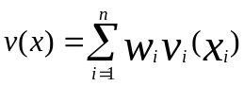
- V(x)-Total Route Score
- V(x)-Score of individual value measure based off of Raw Data
- W-Normalized Swing Weight

The Swing Weight Matrix, Value Functions, and Value Matrix can be seen in their respective appendices.
    - Knockout
The knockout was the highest scored alternative with a score of 72.6. Of the four candidate solutions the knockout exceeded the value measure of number of stops, number of JPODS, Speed of the JPOD, and buildings affected. The weakness of the knockout was the total distance of track, the number of intersections impacted, and human procedures.
    - Visitor Line
The visitor line received a ranking of 3 out of 4 based solely on value. The visitor line exceeded the standard in speed of the JPOD. For every other solution the rote received one of the lowest scores. This is why it received a score of 66.8.
    - Cadet Activities
The route Cadet Activities was a close second to the visitor line. The areas in which it lost to the knock were with the speed of the JPOD and the number of human procedures and the speed of the JPOD. We determined that if value was the only factor in route selection than there would only be a slight difference between Cadet Activities and visitor line.
    - The Tourist
Based on value the tourist ranked the lowest based on value with a score of 64.2. The reason why the tourist ranked so low is that it ranked the lowest for 4 out of the 8 value measures. The areas in which the tourist exceeded in terms of the value was that it impacted few intersection and does not have that many human procedures.
(A direct comparison of each route based on the value measure is in appendix g the stacked bar chart.)
  - Cost
The second factor for the final was based on the cost of the route. The cheaper the route was to produce the better. The cost for each route is in the table below.
Route | Labor Cost | Acquisition Cost | Recurring Cost | Total Cost
Cadet Activities | $ 20,662,461.73 | $180,152,795.3 | $2,900,257.40 | $203,715,514.08
Visitor Line | $ 20,662,461.73 | $180,183,354.4 | $3,480,245.73 | $204,326,061.83
The Tourist | $ 20,662,461.73 | $260,152,795.3 | $2,900,195.44 | $283,715,452.48
Knockout | $20,662,461.73 | $80,213,913.43 | $4,060,306.62 | $104,936,681.78

The cheapest route to produce is the knockout. The reason why it was the cheapest was because of the acquisition cost. The order of routes based on cost following knock out were cadet activities, visitor line, and the tourist. The reason that the tourist was the most expensive was that it crossed the Hudson River.
  - Cost vs. Value
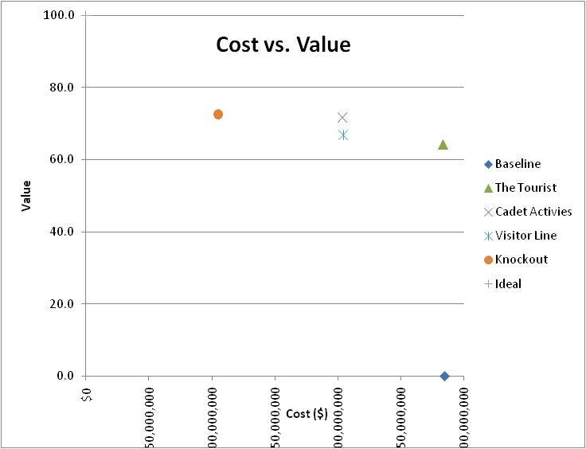
The basis for the final decision is a combination of cost and value. The goal behind the decision was to choose a route that maximized value at a minimum cost. A Cost Vs Value graph is below. It is clear from this graph that the knockout provides the most value at the lowest cost. Both the Cadet Activities and The Tourist are viable options they just don’t provide as much value and cost more. The Visitor Line is the only dominated solution. Dominated means that if you choose this decision there is no positive tradeoff between the cost and the value of the system.

  - Sensitivity Analysis
Since the value measures are a subjective measure based on your preference a sensitivity analysis was performed. This analysis analyzed the top two value measures wait time and human procedures. The method to this analysis is to change the value assigned to the route. As the values are changed the total score changes as well. These changes are then graphed for every route. If the lines of an individual were to cross that would mean that the measure was sensitive. If the lines of a route were to cross in a plus or minus ten window of the original swing weight that would mean the measure is sensitive and it directly affect the results. The graphs for the sensitivity analysis can be seen in Appendix A. The results indicate that none of the values are sensitive.
- Implementation
It will take a considerable amount of time to implement the knockout route on West Point. Implementation of the JPOD system can be broken down into five stages: government coordination, finding workers, acquisition of materials, building the system, and the operation of the system. The knockout route is estimated to take anywhere from 6-8 years to build based on the number of people that are committed to the project. The first step in the implementation of the knockout is coordination. The main coordination that needs to take place is getting the required permits to build the system. The next step for implementation is to find workers to build and operate the system. Many skills sets are required to build the system so it could take a considerable amount of time to find qualified workers. The third step in implementation is to acquire the material necessary to build the JPOD system. The key to this step are to establish the contracts of purchase, find a way to transport the material to West Point. The fourth stage of implementation is to build the system. This will be the longest stage of implementation. It will take up to 28 weeks to build one mile of track. In addition to building tracks, the JPOD stations need to be built, with each station taking up to a year to complete. The final stage of implementation is the operation of the system. One key step in operating the system is that to testing the performance and safety of the system. Testing on the system is important because West Point is a four season climate so it can potentially encounter any type of weather. Conclusion
Based on the research performed by the Decision Makers as well as the cost and value of each of the candidate solutions, our alternative that we recommended is route Knockout. This route performs the best based on what our stakeholders want, the value it possess given the cost, and is overall the most practical route given all elements taken into consideration to finalize a decision. It is essential when coming to a decision that the cost of the system is low compared to the other routes and the value is somewhat high. Thus, route knockout meets these criteria versus other routes that might not fully fulfill the required criteria. To better come to a more concise conclusion, our analysis would be better if the queuing was more concrete and we had more outside sources that were knowledgeable about the JPOD system.
Appendix A
Sensitivity Analysis
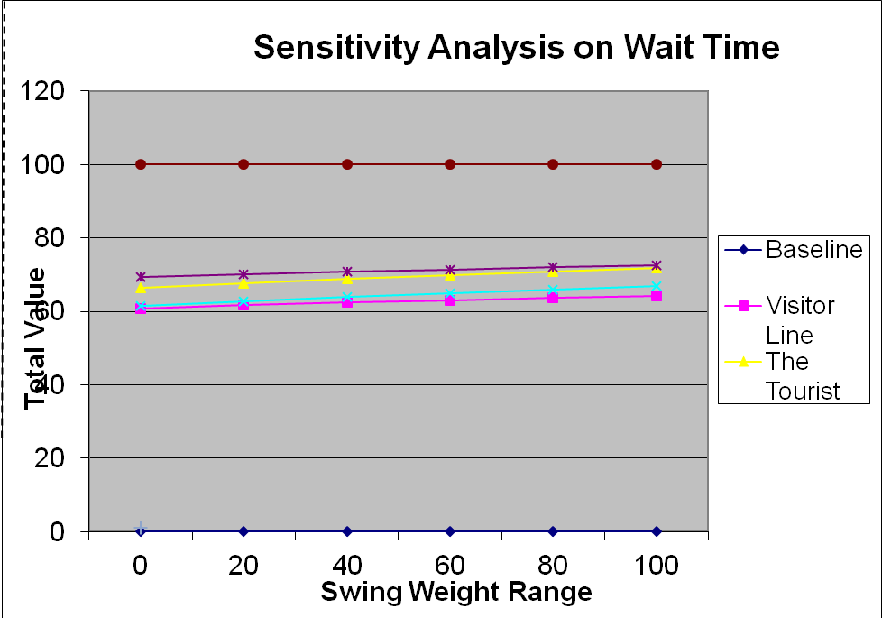
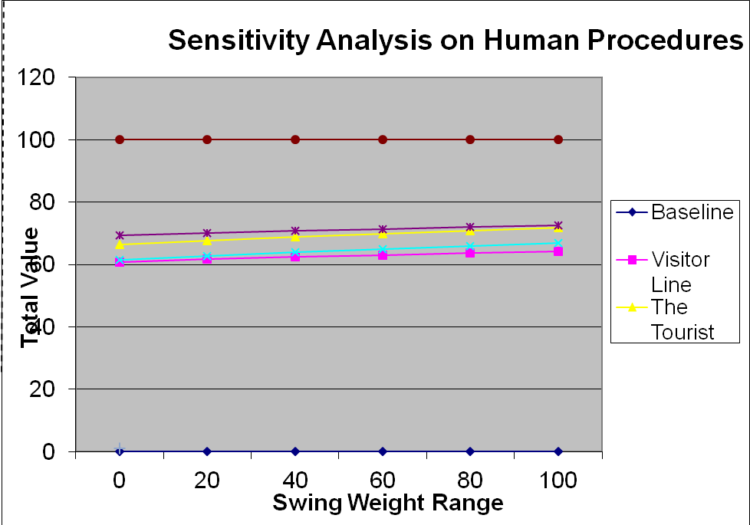
Appendix B
Raw Data Matrix
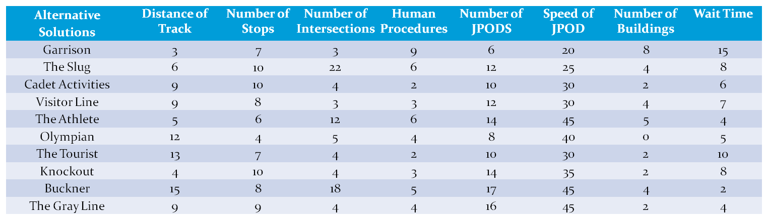
Feasibility Screening Matrix
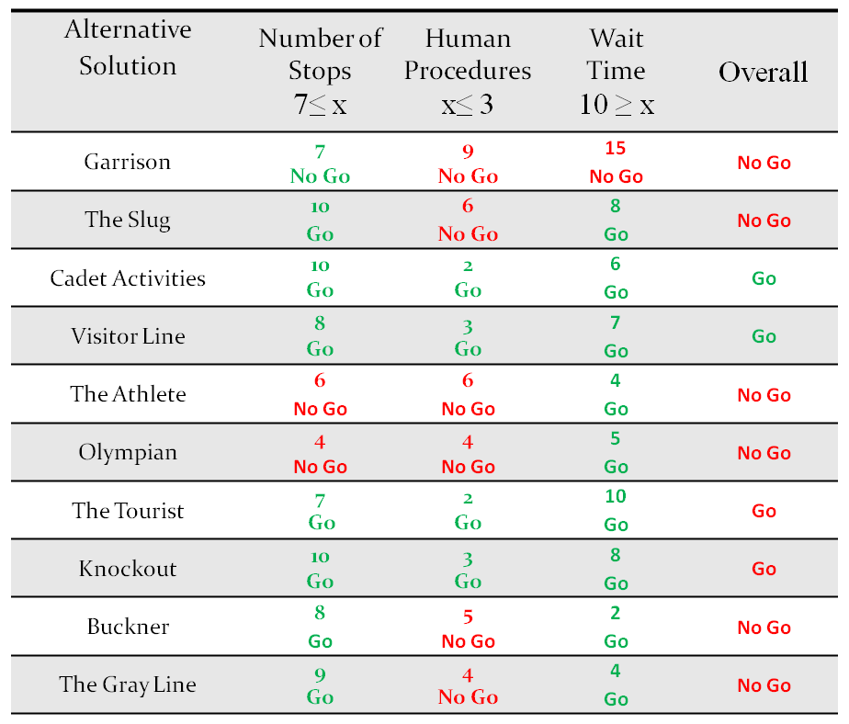
Appendix C Routes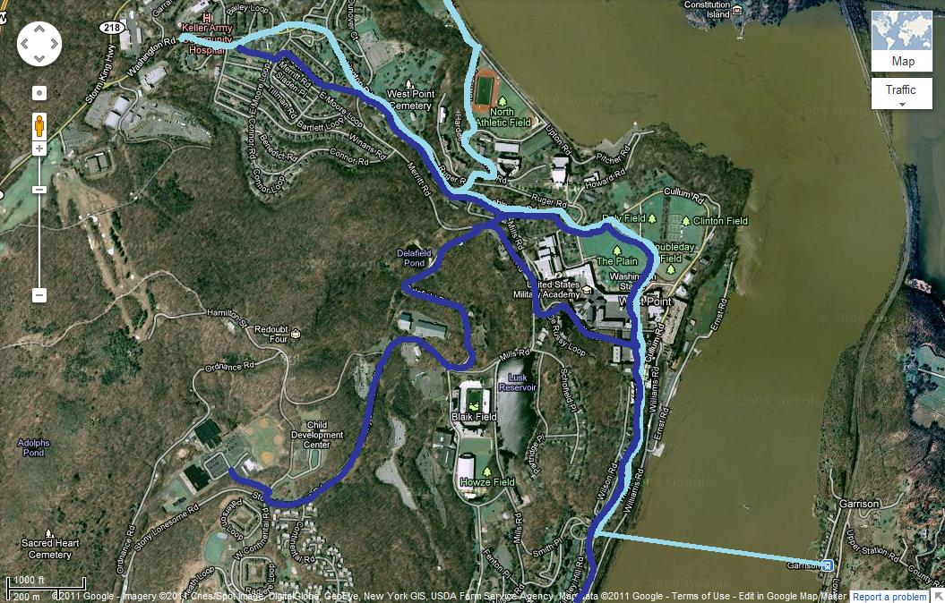
Figure 1 Cadet Activity (sky blue) and Visitor Line (dark blue)

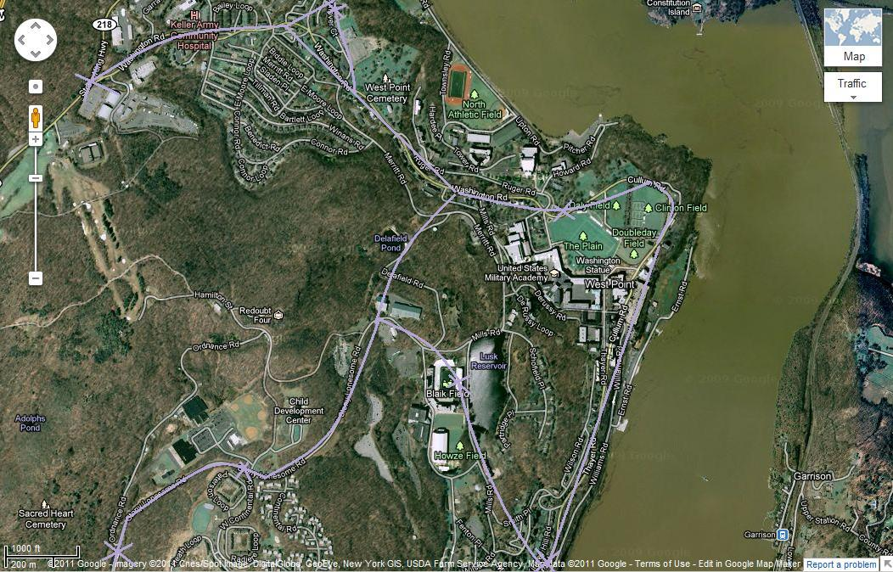
Figure 2 the Tourist
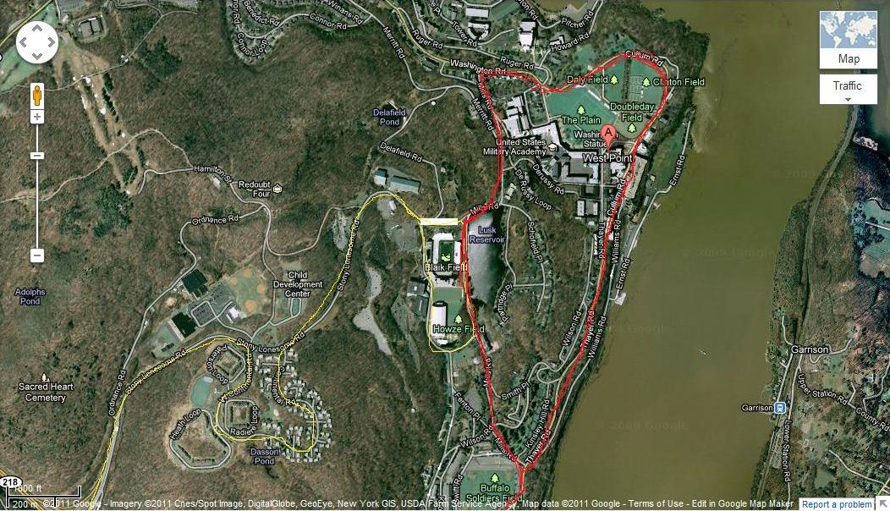
Figure 3 Knockout (red)

Appendix D
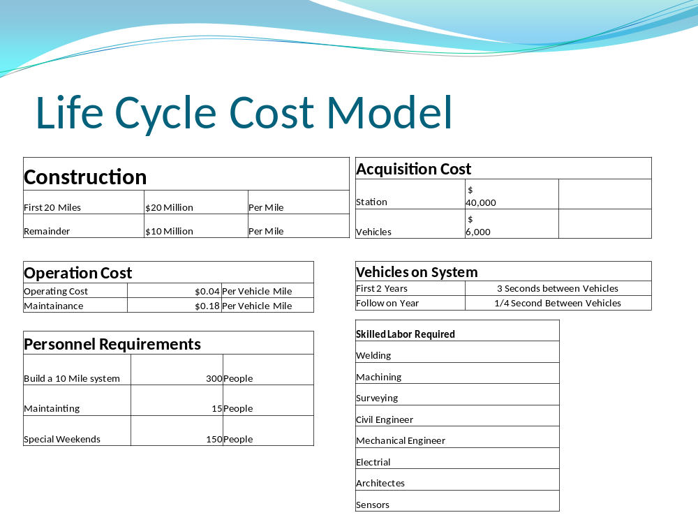
Figure 4 Life Cycle Cost Model

Appendix E
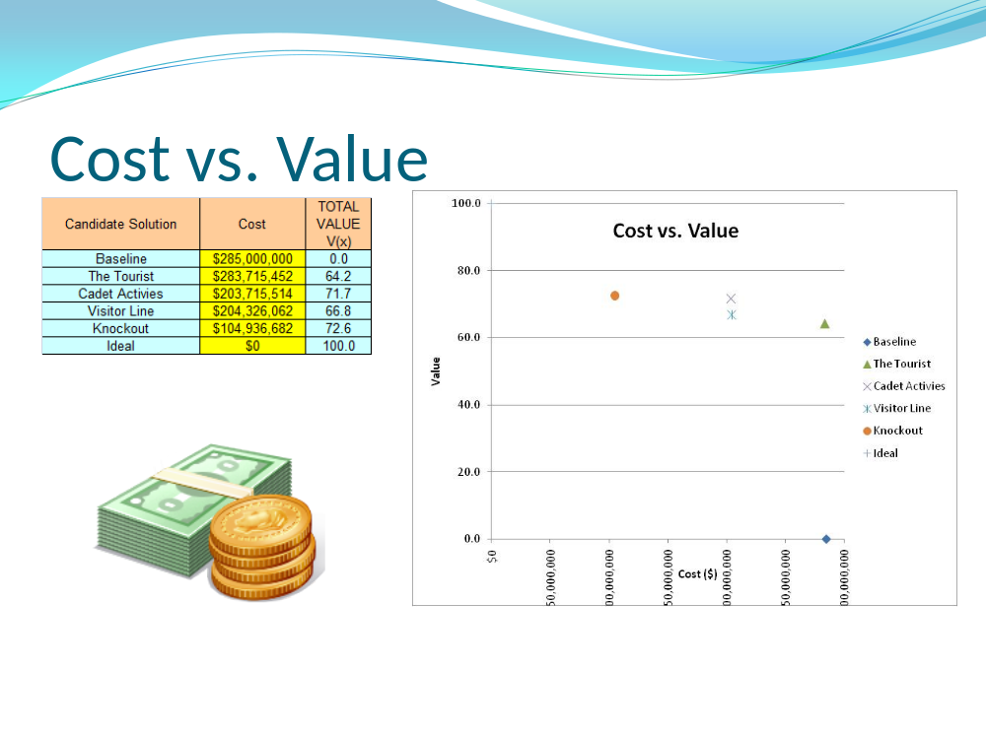
Figure 5 Cost vs. Value

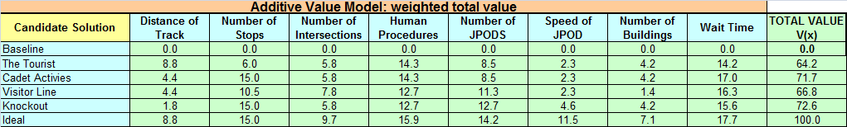
Figure 6 Quantitative Value
Appendix F-IDEF 0
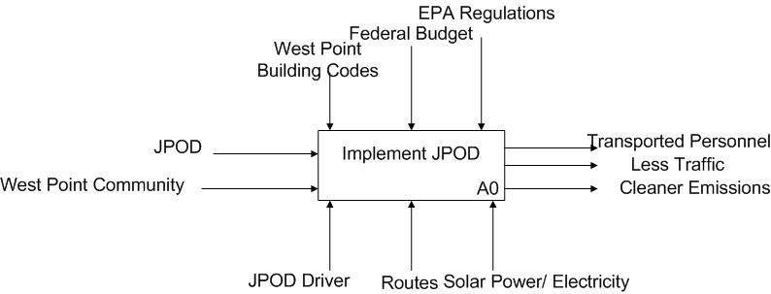

Appendix G- Cost VS Value
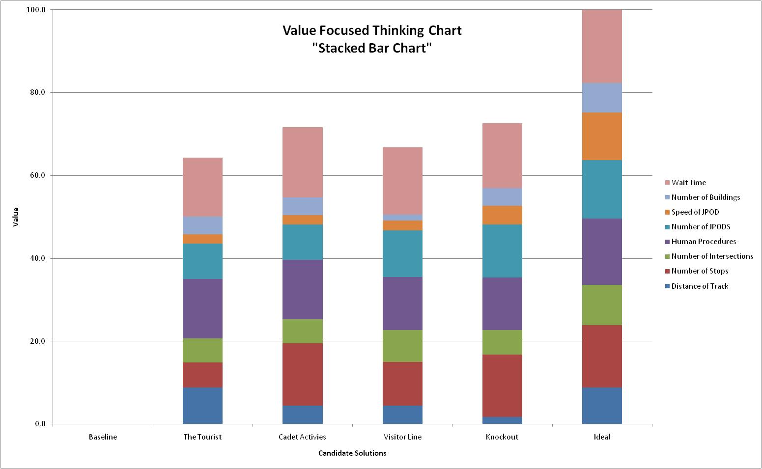
Works Cited
Going Green Sources
Diamond, Jared. “What’s Your Consumption Factor?” New York Times 02 Jan 2011: 14 Sep. 2011 < http://www.nytimes.com/2008/01/02/opinion/02diamond.html>
Harper, Scott. “The military’s new campaign: Cutting its energy costs.” Pilot Online 04 Sep. 2011: 14 Sep. 2011 < http://hamptonroads.com/2011/09/militarys-new-campaign-cutting-its-energy-costsl>
McCain, John. “An Enduring Peace Built on Freedom: Securing America’s Future.” Foreign Affairs 86 (2007): 19-34
Natural Resources Defense Council (NRDC). Safe Strong and Secure: Reducing America Oil Dependence 27 Oct. 2011. 14 Sep 2011. <http://www.nrdc.org/air/transportation/aoilpolicy2.asp>
United States. Department of Defense (DOD). Army Identifies Net Zero Pilot Installations 20 Apr. 2011. 14 Sep 2011 <http://www.defense.gov/releases/release.aspx?releaseid=14420>
United States. US Energy Information Administration. How dependent are we on foreign oil? Jun. 2011. 14 Sep 2011 <http://www.eia.gov/energy_in_brief/foreign_oil_dependence.cfm>
United States. US Environmental Protection Agency. Environmental Tips 11 Jul. 2011. 14 Sep 2011 < http://www.epa.gov/earthday/tips.htm>
United States. US Environmental Protection Agency. Our Mission 14 Sep. 2011. 14 Sep 2011 <http://www.epa.gov/aboutepa/index.html>
Walsh, Bryan. “Top 20 Green Tech Ideas.” Time 06 Dec. 2011: 14 Sep. 2011 <http://www.time.com/time/specials/packages/article/0,28804,2030137_2030135_2021681,00.html>
Walsh, Bryan. “The Surprisingly Long History of Green Energy.” Time 06 April 2011: 14 Sep. 2011 <http://www.time.com/time/printout/0,8816,2063521,00.html>
“Environmentalism.” Merriam Webster Dictionary. Online ed. 2011.
Net zero resources
Ashmccall. "Army’s Net Zero Initiative." Army Live. Army Live, 10 Feb. 2011. Web. 6 Sept. 2011. <http://armylive.dodlive.mil/index.php/2011/02/armys-net-zero-initiative/>.

Assistant of the Secretary. "Army Identifies Net Zero Pilot Installations." U.S Department of Defense. 20 Apr. 2011. Web. 6 Sept. 2011. <http://www.defense.gov/releases/release.aspx?releaseid=14420>.

Booth, Samuel. "Net Zero Energy Military Installations: A Guide to Assessment and Planning." National Renewal of Energy Labatory. Aug. 2011. Web. 6 Sept. 2011. <http://www.nrel.gov/docs/fy10osti/48876.pdf>.

Darden, Allan J. “Draft Finding Of No Significant Impact." Detrick. Web. 7 Sept. 2011. <http://www.detrick.army.mil/emo/NET_ZERO_ENERGY_INITIATIVE_PEA_26JUL2011.pdf>.

Hemmerlybrown, Alexandra. "Army Launches 'Net Zero' Pilot Program | Article | The United States Army." The Official Home Page of the United States Army | The United States Army. 20 Apr. 2011. Web. 05 Sept. 2011. <http://www.army.mil/article/55280/army-launches-net-zero-pilot-program/>.

Personal Raid Transit Sources

Anderson, J. Edward. An Intelligent Transportation Network System: Rationale, Attributes, Status, Economics, Benefits, and Courses of Study for Engineers and Planners. Minneapolis: PRT International, LLC, 2011.

Centers for Disease Control. "CDC - Motor Vehicle Safety." Centers for Disease Control and Prevention. http://cdc.gov/motorvehiclesafety/index.html (accessed September 13, 2011)

James, Bill. Interview by SE450 B Hour. Personal interview. Mahan Hall, September 7, 2011.

Lowson, Martin V.. A New Approach To Sustainable Transport Systems. London: World Clean Air an
Environmental Protection Congress , 2004.
McCall, Ash. "Armyâ€™s Net Zero Initiative." Army Live. http://armylive.dodlive.mil/index.php/2011/02/armys-net-zero-initiative/ (accessed September 13, 2011).
Vuchic, Vukan R.. "Personal Rapid Transit: An Unrealistic System." Urban Transport International, Sep. - Oct. 1996.

